MATH 107 Final Exam

MULTIPLE CHOICE Select the best answer choice. Write your answer choices below:

- __C___

- _D____

- __B___

- __A___

- ___B__

- __C___

- __C___

- __B___

- __C___

- __B___

- (i) _B,C,D__ (ii) B___ (iii)___D_

- __C___

- __D___

- __C___

- __A___

- __B___

- __C___

- __A___

- __A___

- __D___

(1) Find the slope-intercept equation of the line pictured below. Show work.
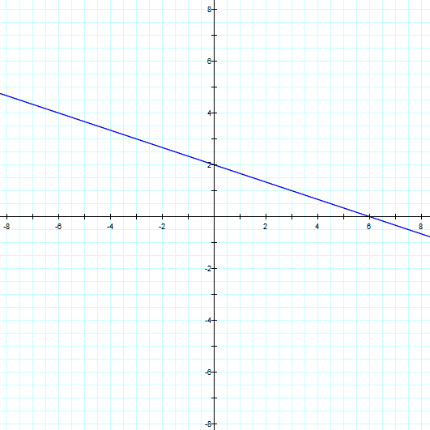

$$\left(A\right) y=−2x+6 \left(B\right) y=−\frac{2}{5}x+2 \left(C\right) y=−\frac{1}{3}x+2 \left(D\right) y=\frac{1}{3}x+6 \left(E\right) none of the above$$
Solution:

(2) Find the equation of the line passing through the two points: (3, 7) and (-3, 5).
$$\left(A\right) y=−3x+16 \left(B\right) y=3x−2 \left(C\right) y=−\frac{1}{3}x+8 \left(D\right) y=\frac{1}{3}x+6 \left(E\right) none of the above$$
Solution:

(3) Find the midpoint of the line segment with the given endpoints: (–8, 4) and (2, 6).
$$\left(A\right) \left(5, 1\right) \left(B\right) \left(−3, 5\right) \left(C\right) \frac{2}{5} \left(D\right) 2\sqrt{26} \left(E\right) none of the above$$
Solution:

(4) Maximizing Area. A homeowner wants to fence a rectangular play yard using 60 feet of fencing. The side of the house will be used as one side of the rectangle. Find the dimensions for which the area is a maximum.
$$\left(A\right) 15 ft by 30 ft \left(B\right) 20 ft by 40 ft \left(C\right) 40 ft by 40 ft \left(D\right) 40 ft by 80 ft \left(E\right) none of the above$$
Solution:

(5) Analyze each of the four graphs as requested below. (no explanation required.) The graph is symmetric with respect to:
$\left(A\right) x−axis \left(B\right) y−axis \left(C\right) origin \left(D\right) no symmetry \left(E\right) none of the above$
$$y$$
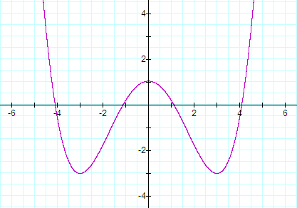
$$x$$
Solution:

(6) Find the domain of $f\left(x\right)=\sqrt{x^{2}+x−6}$ in interval notation.
$$\left(A\right) \left(−∞, −3\right)∪\left(2, ∞\right) \left(B\right) \left(−∞, −4\right]∪\left[3, ∞\right) \left(C\right) \left(−∞, −3\right]∪\left[2, ∞\right) \left(D\right) \left[0, ∞\right) \left(E\right) none of the above$$
Solution:

(7) Express the following as a single logarithm:
$${5 log}_{3}{x+}\frac{2}{3}\log_{3}{y−\log_{3}{15z}}$$
$$\left(A\right) \log_{3}\left(x^{3}+y^{3/2}−15z\right) \left(B\right)\log_{5}\left(\frac{x^{3}\sqrt{y^{3}}}{15z}\right)$$
$$\left(C\right) \log_{3}\left(\frac{x^{5} \sqrt[3]{y^{2}}}{15z}\right) \left(D\right) \log_{5}\left(\frac{3xy^{3/2}}{5z}\right) \left(E\right) none of the above$$
Solution:

(8) A country’s population doubled in 15 years. What is the exponential growth rate? Round your decimal answer to the nearest hundredth.
$$\left(A\right) 0.02 \left(B\right) 0.05 \left(C\right) 0.15 \left(D\right) 10.40 \left(E\right) none of the above$$
Solution:

(9) Find $\left(f o g\right)\left(x\right)$ if $g\left(x\right)=f^{−1}\left(x\right)$ is the inverse of the function $f\left(x\right)$.
$$\left(A\right) 1 \left(B\right) g/f \left(C\right) x \left(D\right) not enough information \left(E\right) none of the above$$
Solution:

(10) Given the graph of the function $y=f\left(x\right)$, find the domain of the inverse function $f^{−1}\left(x\right)$.
$$y$$
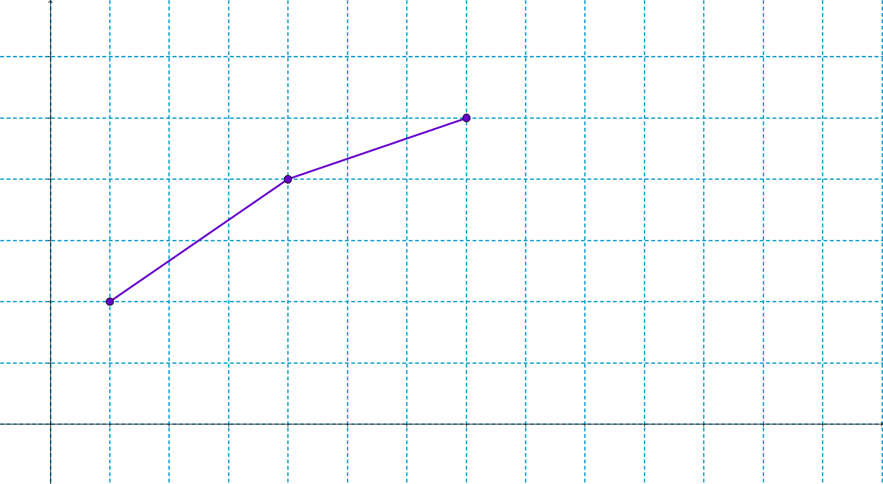
$$y=f\left(x\right)$$
$$x$$
$$5$$
$$4$$
$$3$$
$$2$$
$$1$$
$$7$$
$$6$$
$$5$$
$$4$$
$$3$$
$$1$$
$$2$$
$$\left(A\right) \left[1, 7\right] \left(B\right) \left[2, 5\right] \left(C\right) \left[2, 7\right] \left(D\right) \left[1, 5\right] \left(E\right) none of the above$$
Solution:

(11) (No explanation required)
(A)  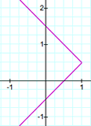 | (B)  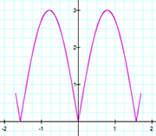 | (C)  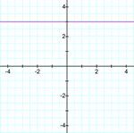 | (D)  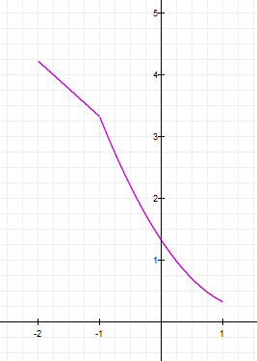

(i) Which of these graphs represents a function? Answer(s): _______________
(ii) Which of these graphs represents an even function? Answer(s): _____________
(iii) Which of these graphs represents a one-to-one function? Answer(s): ____________

(12) Consider the following graph of $y=f\left(x\right)$. Determine the value of $f\left(−2\right)$.
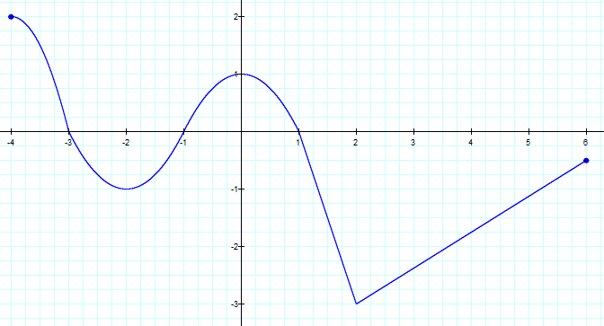

$$\left(A\right)−3 \left(B\right) 1.75 \left(C\right)−1 \left(D\right) 0 \left(E\right) none of the above$$
Solution:

(13) A graph of $y=f\left(x\right)$ is given. Which graph (A, B, C, or D) represents the graph of $y=f\left(x+1\right)+2$? Briefly Explain how you have decided which graph is the correct one.
2
4
-2
-4
-2
-4
2
4
y = f(x)

$\left(A\right)$ $\left(B\right)$
2
4
-2
-4
-2
-4
2
4
2
4
-2
-4
-2
-4
2
4

2
4
-2
-4
-2
-4
2
4
$\left(C\right)$ $\left(D\right)$
2
4
-2
-4
-2
-4
2
4

$$\left(E\right) none of the above$$
Solution:

(14) Find the domain of the function below in interval notation:
$$f\left(x\right)=\frac{\sqrt{x − 5 }}{x − 8 }$$
$$\left(A\right) D=\left(−∞, 8\right)∪\left(8, ∞\right) \left(B\right) D=\left[5, ∞\right) \left(C\right) D=\left[5, 8\right)∪\left(8, ∞\right) \left(D\right) \left[5, 8\right) \left(E\right) none of the above$$
Solution:

(15) Based on data for 1990 - 2015 retrieved from https://stateofobesity.org/states/md/ , the following chart of Maryland obesity rates has been prepared.
What is the slope of the regression line and what are the units of measurement? In a sentence, interpret what the slope is telling us, in the context of this real-world application.

$$\left(A\right) 0.7463 \left(B\right)−0.7463 \left(C\right) 0.9859 \left(D\right) 0.9929 \left(E\right) none of the above$$
Solution:

(16) Solve for $x$: $4^{\sqrt[3]{x}}=8$
$$\left(A\right) \sqrt[3]{\frac{3}{2}} \left(B\right) \frac{27}{8} \left(C\right) 8 \left(D\right) \sqrt[3]{2} \left(E\right) none of the above$$
Solution:

(17) Solve $\log_{3}{x+\log_{3}\left(x+8\right)=2}$.
$$\left(A\right) x=1 and x= −9 \left(B\right) x=2 \left(C\right) x=1 \left(D\right) x=−9 \left(E\right) none of the above$$
Solution:

(18) Find $a$ such that $f\left(x\right)=ax^{2}−4x−3$ has a maximum value of 9.
$$\left(A\right) a=−\frac{1}{3} \left(B\right) a=−3 \left(C\right) a=−\frac{4}{9} \left(D\right) a=9 \left(E\right) none of the above$$
Solution:

(19) Suppose $f\left(x\right)=x^{2}$ over the domain of $f$, then:
$$\left(A\right) f^{−1}\left(x\right)=\sqrt{x} \left(B\right) f^{−1}\left(x\right)=\frac{x}{2} \left(C\right) f^{−1}\left(x\right)=−x^{2}$$
$$\left(D\right) f^{−1}\left(x\right) does not exist \left(E\right) none of the above$$
Solution:

(20) A rectangular piece of land to be developed as a memorial park has an area of $75 m^{2}$. The length of the lot is three times the width of the lot. A rectangular path whose width is $x$ meters is to be constructed along the inner perimeter of the lot. The land contained within the path will be landscaped. The cost to construct the path is $\$2$ per square meter and the cost to landscape the inner field is $\$3$ per square meter. Express the total cost to develop this lot as a function of $x$, the width of the path.
$$\left(A\right) C\left(x\right)=12x^{2}−96x+144, x>0 \left(B\right) C\left(x\right)=4x^{2}−32x+144, x>0$$
$$\left(C\right) C\left(x\right)=12x^{2}−120x+225, x>0 \left(D\right) C\left(x\right)=4x^{2}−40x+225, x>0 \left(E\right) none of the above$$
Solution:

